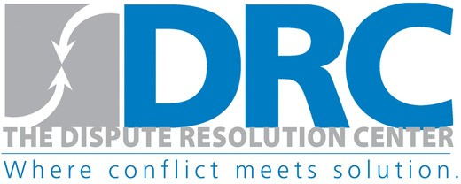
4133 Washtenaw Ave, Ste B125, Ann Arbor, MI 48107, PO BOX 8625
734.794.2125 | thedisputeresolutioncenter.org | thedrc@thedrcmi.org

Date:
Court Case #:
DRC #:

VIRTUAL CIRCLE CONSENT FORM
The purpose of this session is to help people settle disputes.
Please let us know if there is anything you need that would make this time more helpful to you.

By signing this form I agree that:

- Coming to the virtual session is voluntary, unless it was ordered by a court.
- No other persons will be in the room or in listening distance; and no person will take pictures or record the session.
- I understand that the facilitator won’t take sides or tell people what to do.
- I will listen to everyone.
- I will be respectful and not interrupt when others are talking.
- I won’t call anyone names.
- If we do not reach agreement, I may use other ways to resolve the conflict.
- The process is confidential; facilitators may not be called into court as witnesses.
- But, if facilitators hear about abuse, neglect, threats, or actions of bodily harm they will report this information to the proper authorities.
- If we reach an agreement, I will do what I said I would do.
If an agreement is reached, the Dispute Resolution Center may follow up to find out if the agreement is working.

The following people have given verbal consent for virtual signing:

Name |  | Name
Name |  | Name
Name |  | Name
Name |  | Name
Name |  | Name

